PYTHON

## Create a python file:

* Windows search - > Idle
* Open python idle
* File - > New File (A new file will be created)
* Press ctrl + s or File - > Save (To save file)

**Note**: Save file with extension as .py

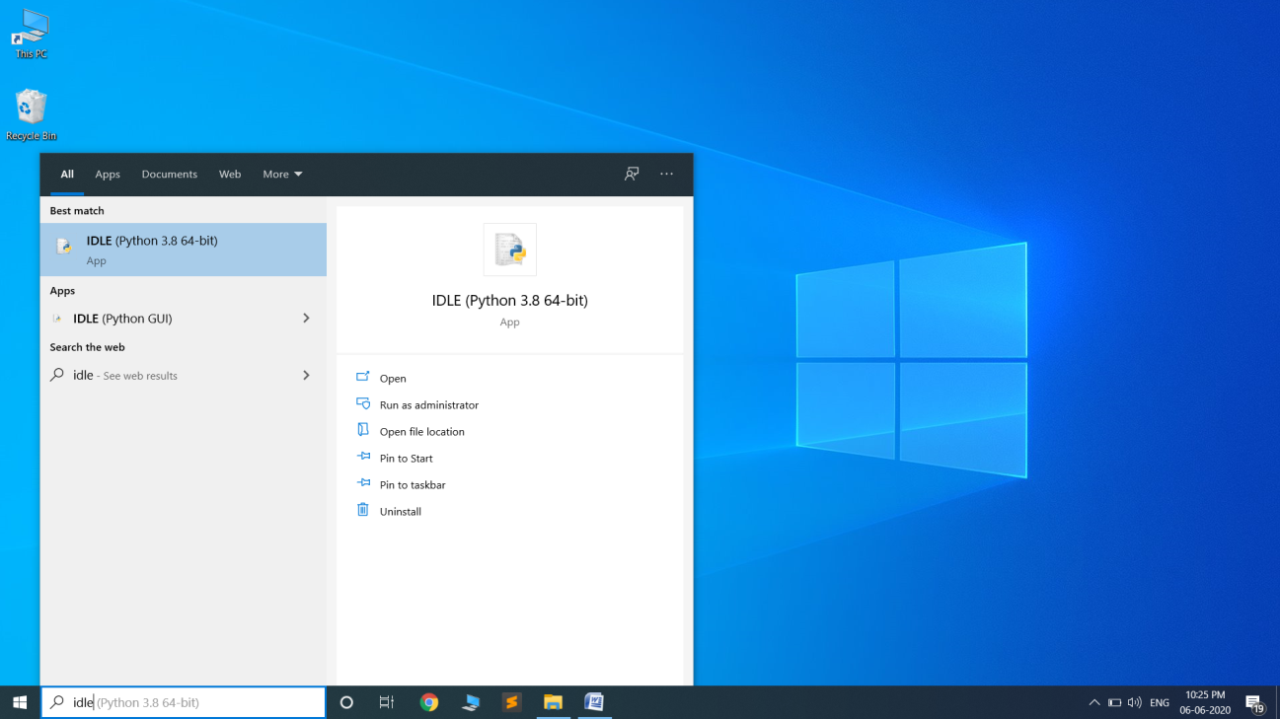

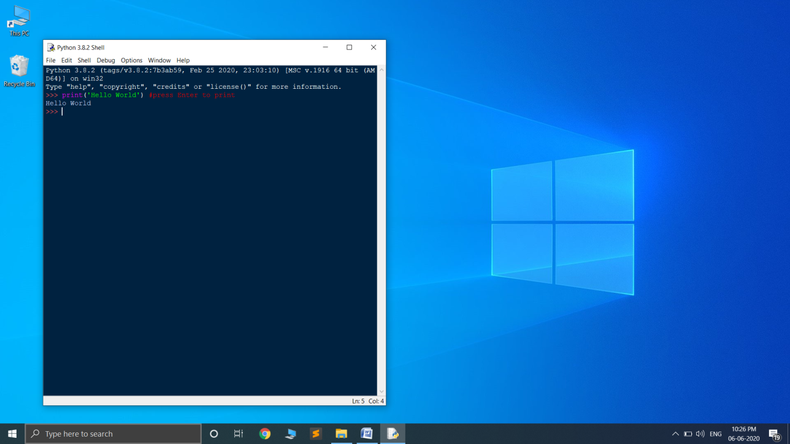  
(Note: Your idle will be in light theme, the above idle is in dark theme)

## First Hello World Program:

print(‘Hello World’)

* Ctrl + s
* save file as HelloWorld.py
* press F5 or run - > Run Module (To execute your code)

# Notes:

## Comment line in python

# - is used to comment a line in python

‘’’ ‘’’ – is used to comment multi-line comment

Example:

#this is a single line comment

‘’’

This

Is

A

Multi-line

Comment

‘’’